KiZAN IoT Workshop

Lab Exercises

# Lab 1 – Blinking LED

## Goal

The goal of this exercise is to build a simple LED circuit using a Windows IoT Core device (Raspberry Pi 2, in our case) and then blink the LED with an app built and debugged with Visual Studio 2015.

## Requirements

Prior to starting this exercise, please ensure that you meet the following requirements.

### Hardware

Please verify that you have the following components:

1. Raspberry Pi 2 Model B w/ EDIMAX Wifi Adapter
2. Wall Adapter Power Supply
3. Raspberry Pi GPIO Ribbon Cable
4. SparkFun Pi Wedge Breakout Board
5. Breadboard
6. (1) Red LED
7. (1) 330 Ohm Resistor
8. (2) Red Jumper Wires M/M
9. (1) Black Jumper Wire M/M

### Software

Please verify that you have the following software installed on your Windows 10 laptop:

1. Visual Studio 2015 Community Edition (or greater)

<https://www.visualstudio.com/vs-2015-product-editions>

1. Windows 10 IoT Core Dashboard

<https://developer.microsoft.com/en-us/windows/iot/downloads>

### Networking

To communicate with the Raspberry Pi 2, you must be connected to the following Wifi network:

|  |  |
| --- | --- |
| SSID | Password |
| iotlab | p@ssw0rd |

## Part 1 – Circuit Assembly

1. Carefully attach the SparkFun Pi Wedge Breakout Board to the Breadboard, ensuring that the pins on the Pi Wedge align with the pin holes on the Breadboard.

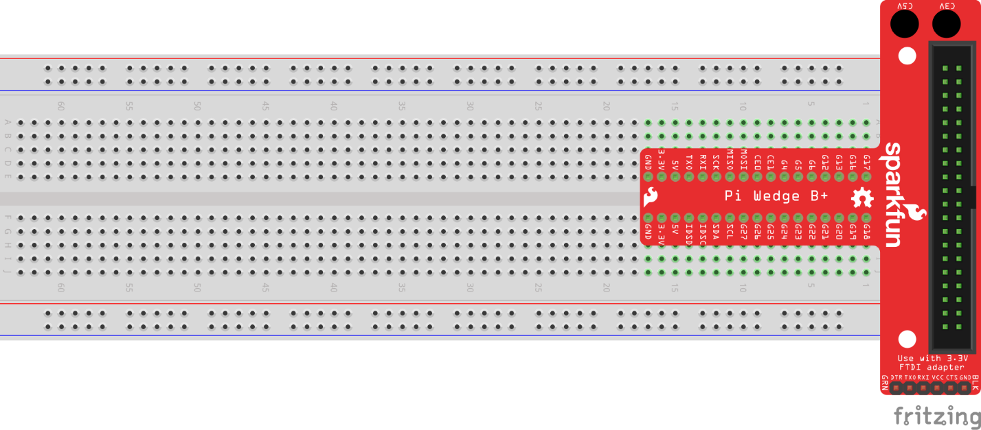

Figure 1 - SparkFun Pi Wedge connected to the Breadboard

1. Using the Raspberry Pi GPIO Ribbon Cable, connect the Pi Wedge Breakout Board to the Raspberry Pi GPIO header. Note: the connector on the ribbon cable is notched so that it will only connect to the Pi Wedge if oriented appropriately.
2. Place the Red LED along the field of the breadboard, noting that the anode of the LED (the longer lead) is positioned on the right.

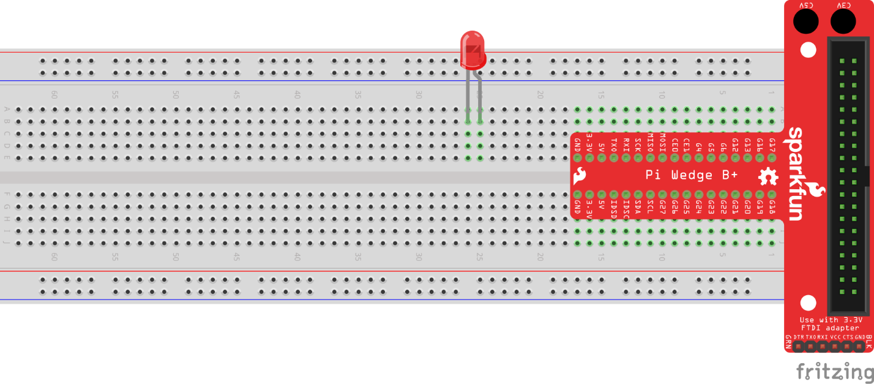

Figure 2 - Red LED placed on the Breadboard

1. Connect the 330 Ohm resistor to the anode (the longer lead) of the LED and land the opposite lead of the resistor to the directly across the centerline of the breadboard.

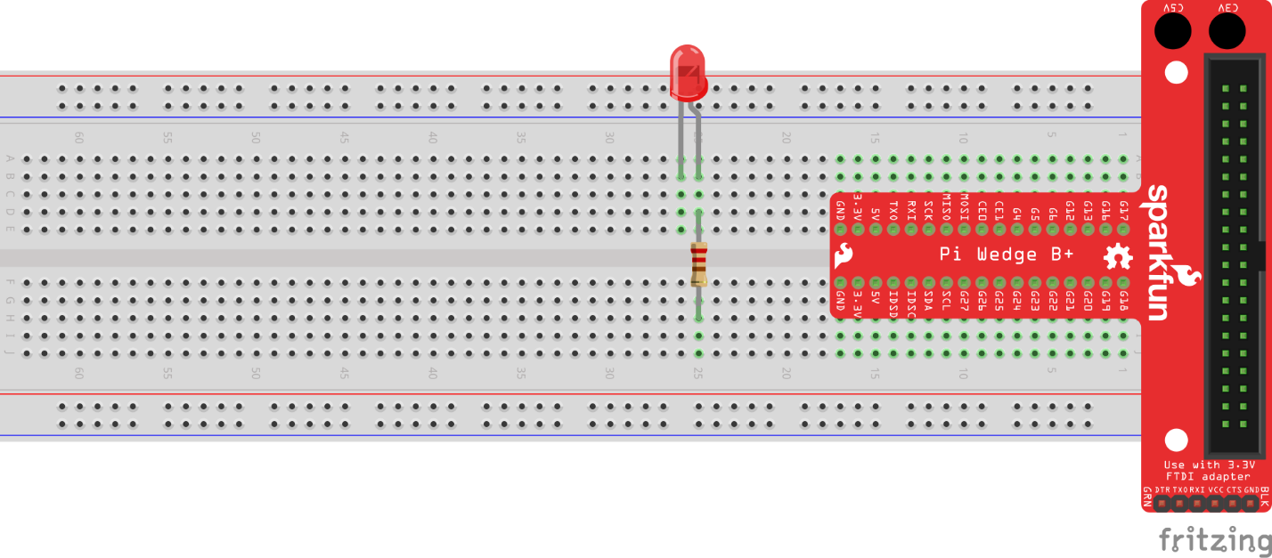

Figure 3 - 330 Ohm resistor placed on the Breadboard

1. Using a Red Jumper Wire, connect one end to the cathode (the shorter lead) of the LED. Connect the opposite end to the pin labeled *G4* on the SparkFun Pi Wedge Breakout Board.

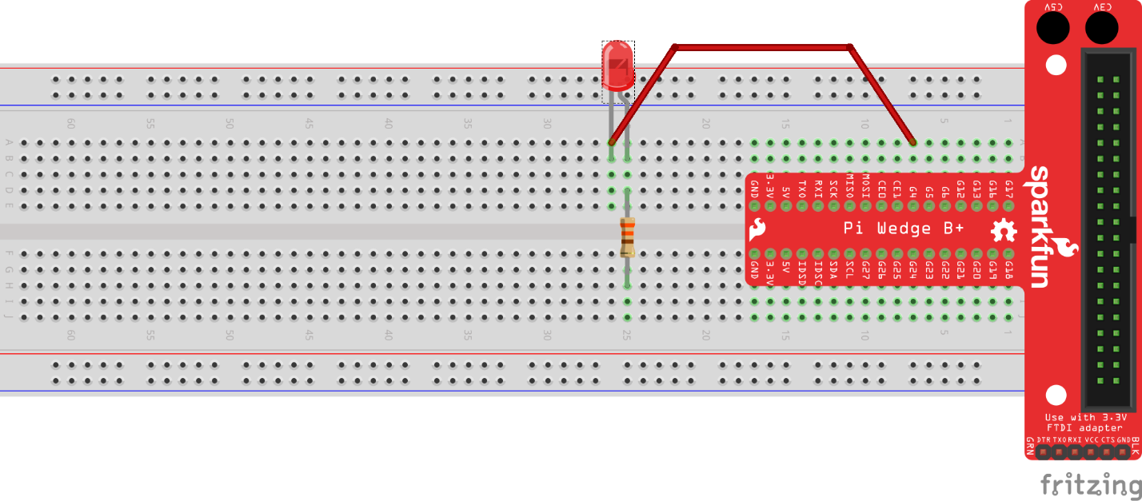

Figure 4 - Red LED connected to G4 pin on the Pi Wedge

1. Using a Red Jumper Wire, connect one end to the end of 330 Ohm resistor located in the bottom field of the breadboard. Connect the opposite end to the positive (+) channel of pins located on the bottom of the breadboard.

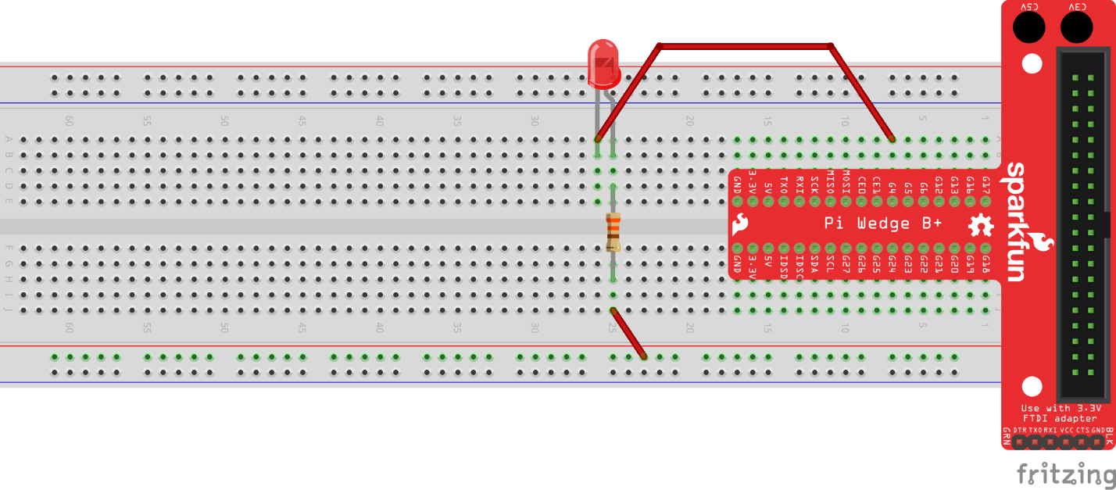

Figure 5 - 330 Ohm resistor connected to the positive pin channel

1. Using a Black Jumper Wire, connect the positive (+) channel of pins to the pin labeled *3.3V* on the SparkFun Pi Wedge.

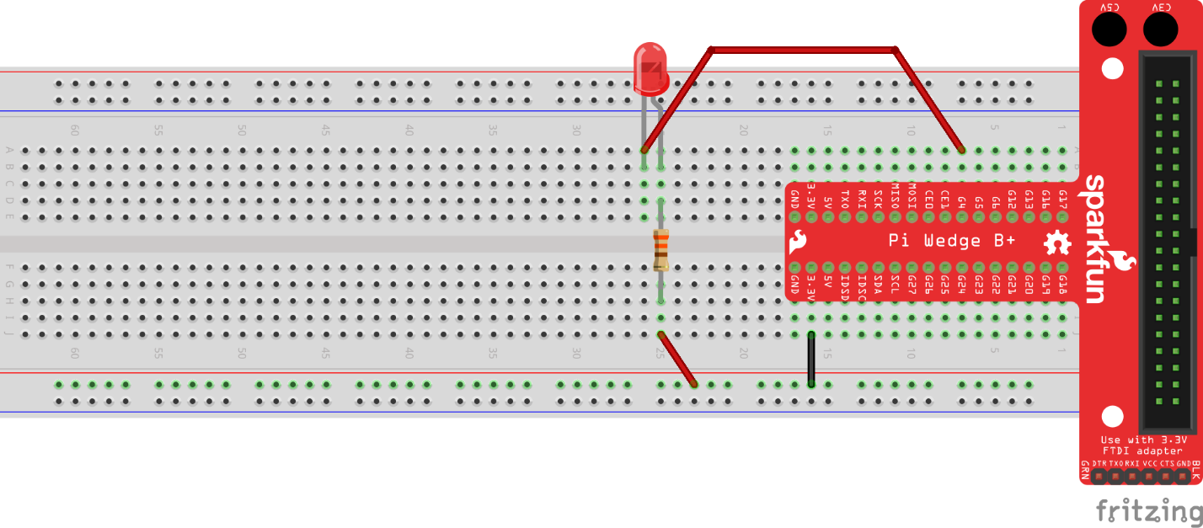

Figure 6 - Positive (+) pin channel connected to 3.3V pin on the Pi Wedge

## Part 2 – Code

1. Connect the Wall Adapter Power Supply to the micro USB port on the Raspberry Pi. Next, plug in the Wall Adapter Power Supply.
2. Open the Windows 10 IoT Core Dashboard application. Once your device has completed its power up sequence, you should see your device in the list of *My devices*.

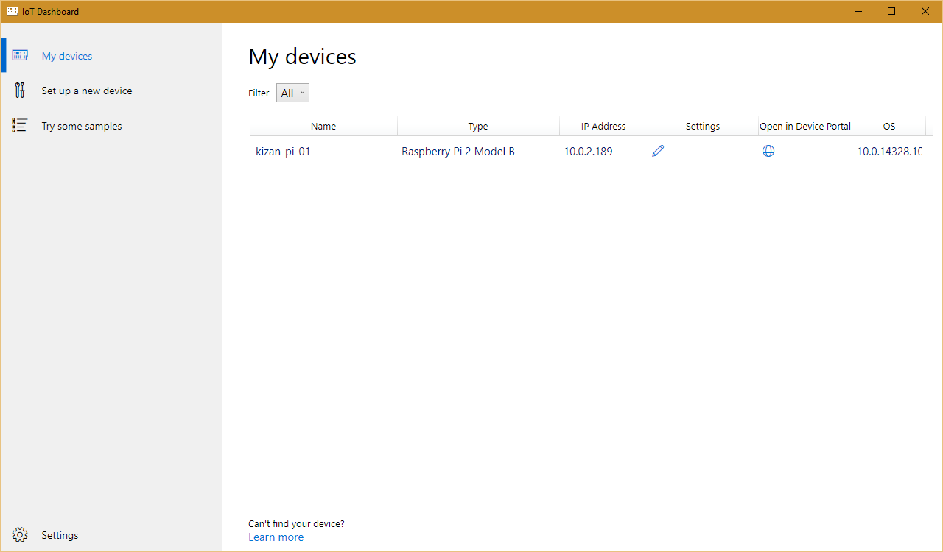

Figure 8 - Windows 10 IoT Core Dashboard

1. Using Visual Studio 2015, open the Lab01.sln solution from the downloaded source package. Lab01.sln is located in the *KiZAN-IoT-Workshop\src\Lab01* folder.
2. Verify that the Debug configuration and ARM platform are selected.



Figure 9 - Build Configuration and Platform

1. Next, change Run from Device to Remote Machine.

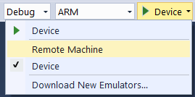

Figure 10 - Change Run from Device to Remote Machine

1. In the Remote Connections dialog box, find your device in the list of Auto Detected devices. Select your device, and click the Select button.

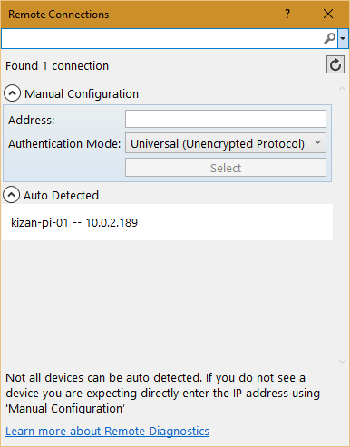

Figure 11 - Remote Connections

1. Press F5 to run the application. Visual Studio will restore any missing NuGet packages, build the application, and then deploy the application to the remote machine. Shortly after deploying the application, you should observe the Red LED blinking intermittently.
2. Stop debugging.
3. Using Windows 10 IoT Core Dashboard, click the globe icon in the *Open in Device Portal* column for your device.
4. When prompted enter the following User Name and Password.

|  |  |
| --- | --- |
| User Name | Password |
| Administrator | p@ssw0rd |

1. In the upper, right-hand corner, click Power, and then click Shut down.

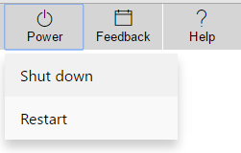

Figure 12 - Power Menu

1. When prompted to confirm, press OK.
2. It is safe to remove power when the Device Portal prompts to “Restart the device to reconnect”.